**Report**

**Business Problem**

My client is a funerary parlour operator in the city of Barcelona, Spain, who is about to resume operations on its first funerary parlour and is looking to identify which neighborhood / s are suitable to set up a commercial office.

This requires defining what features should a suitable neighborhood have. In my perspective, it would be convenient if (i) there’s a high density of population, (ii) there’s a high % of population over 65 years of age and (iii) there’s a high concentration of interesting venues nearby (defining an interesting venue as a venue where the elder tend to frequent therefore increasing the chances of commercialising funerary parlour related products).

I will therefore require a comprehensive list of Barcelona’s neighborhoods with their latitude / longitude data, their population by age segment, and a list of relevant nearby venues.

**Data**

To solve the described business problem I have had to leverage the subsequent data from the following sources:

1. Website: by doing web scrapping on a local council stats data I download a list of neighborhoods by postal code with their respective population data by age range (which requires some data cleaning)

This is the resulting dataframe:

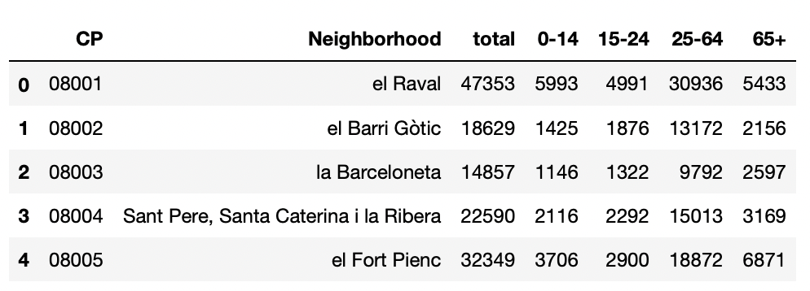

To complement this, I utilise the geocoding library to retrieve the latitude / longitude data per neighborhood.

This is the resulting merged dataframe:

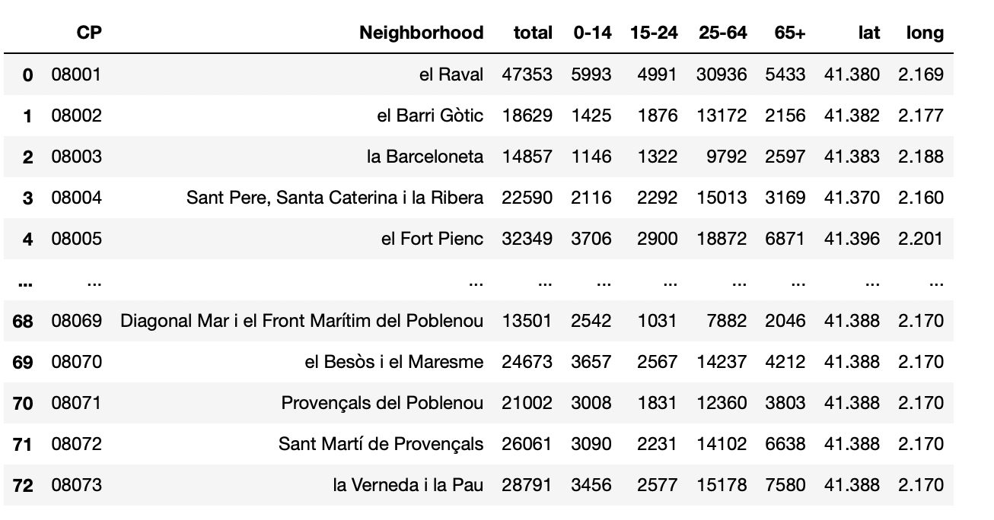

1. Foursquare API: I use the Foursquare API to retrieve a list of nearby venues by neighborhood which I then categorise according to whether they are interesting or not to respond to the business question

This is the Foursquare API data:

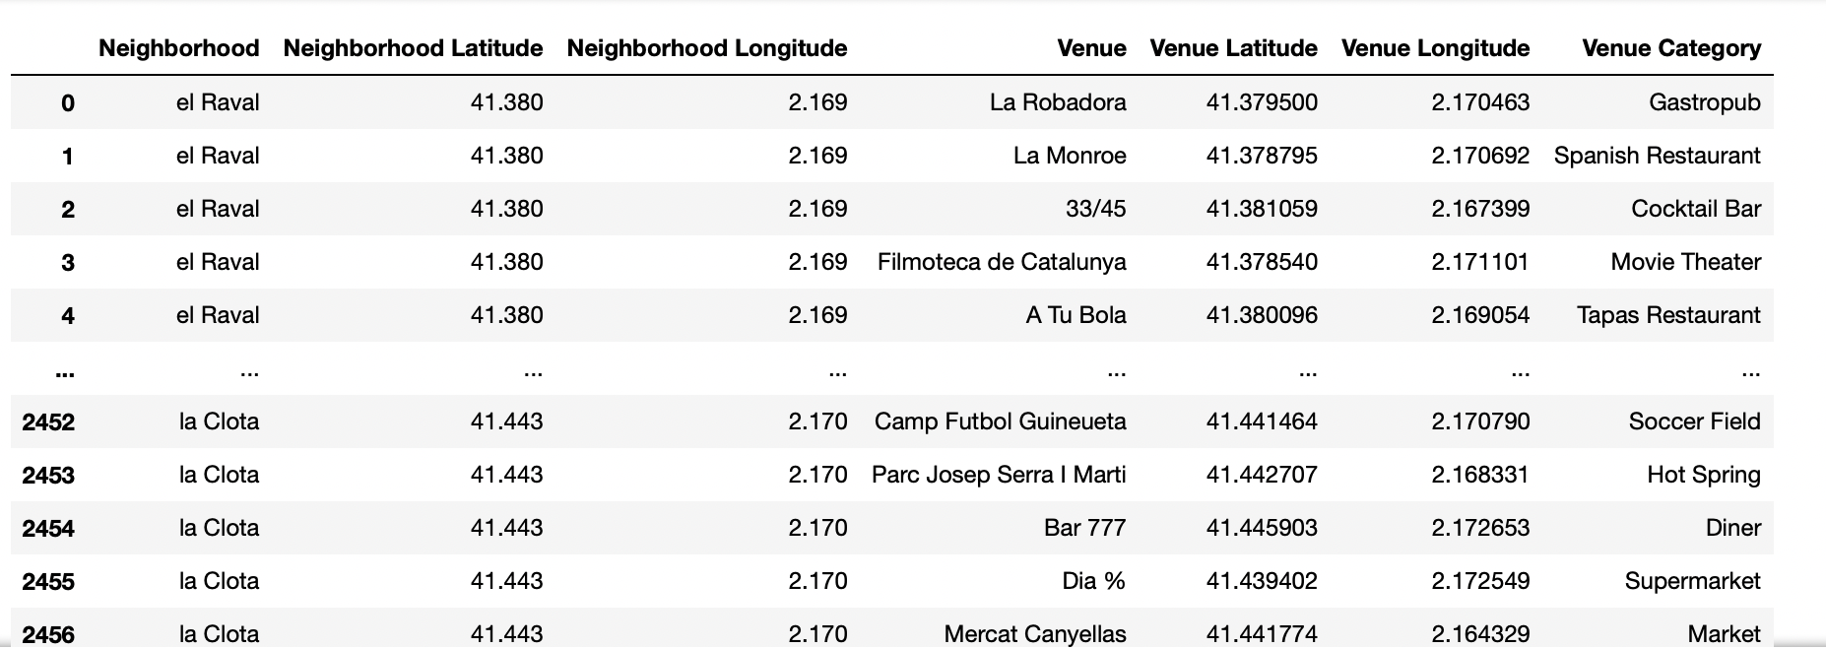

I look at the unique venues list to define what the interesting venues mnight be:

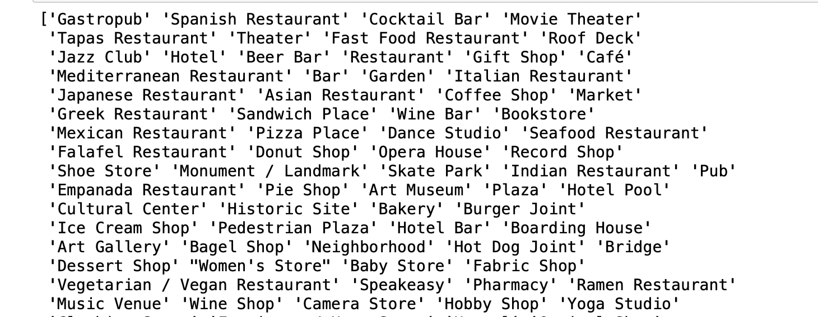

I then define the interesting venues and calculate the number of interesting venues per neighborhood:

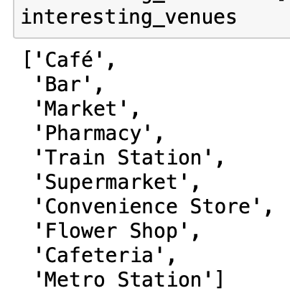

This is the resulting merged dataframe:

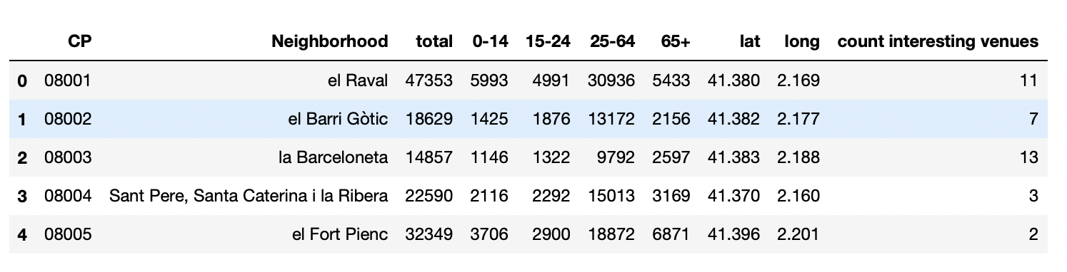

This is the final and clean dataframe to perform the K-Means clustering algorithm on which contains the initial 3 variables I wanted to consider (i) ‘total’ is the total population, (ii) ‘65+’ is the population above 65 years of age and (iii) ‘count of interesting venues’ is the number of interesting nearby venues:

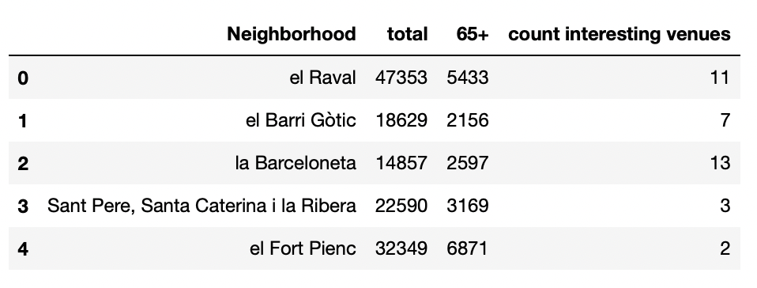

**Methodology**

I look at the neighborhood location on a map using Folium:

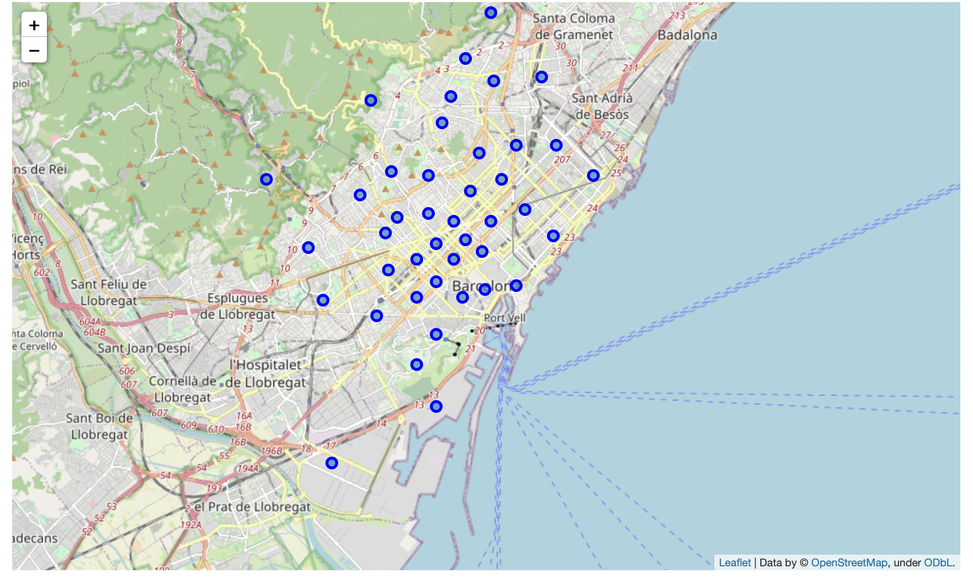

I look at the total population per neighborhood to see the high density areas.

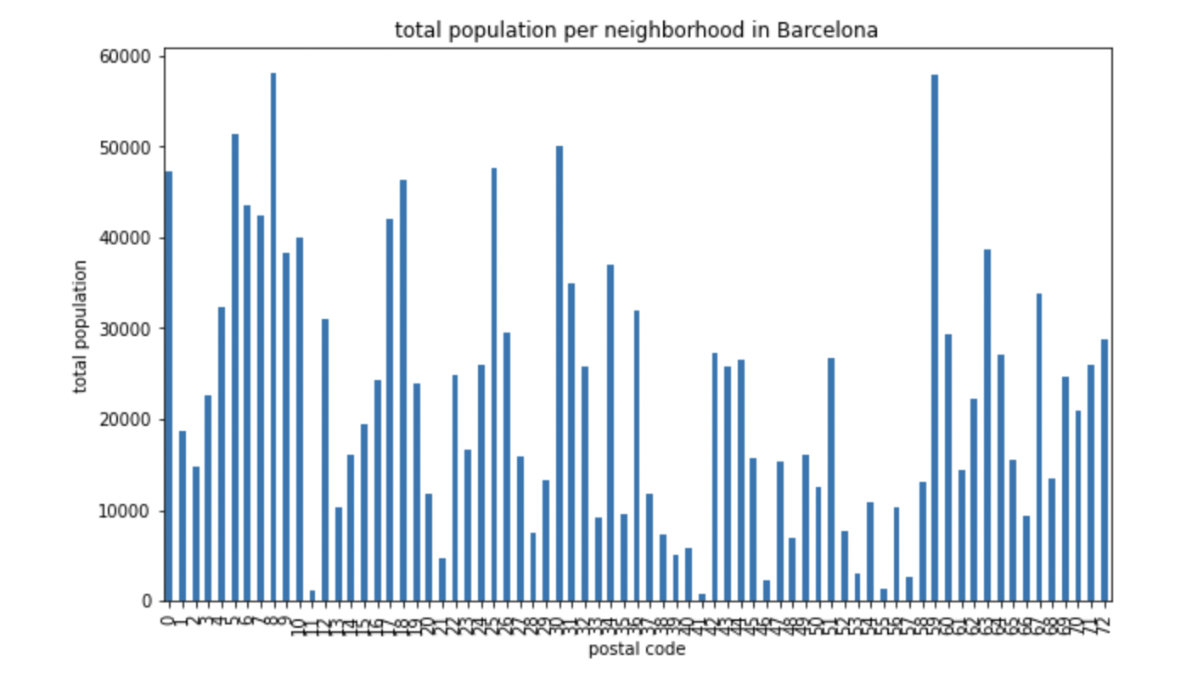

I look at the proportion of the age segment population over 65 years of age over total population per neighborhood:

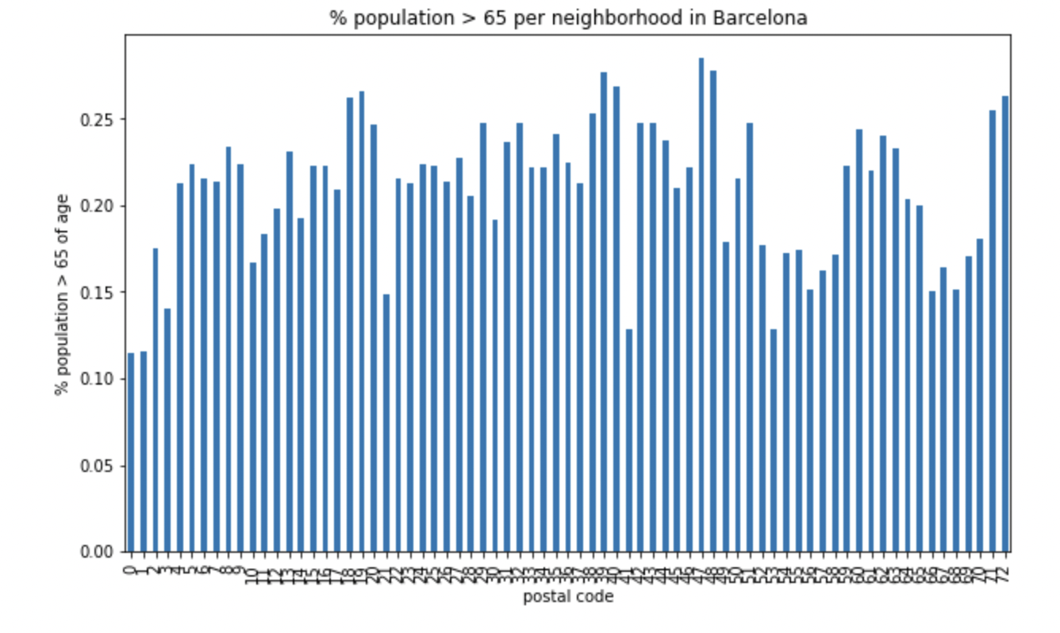

I finally use K-Means clustering to segment the neighborhoods according to the given set of features that I find relevant for the business problem.

**Results**

The resulting dataframe after performing the clustering algorithm looks as follows:

The visual representation of the clustered neighborhoods looks as follows:

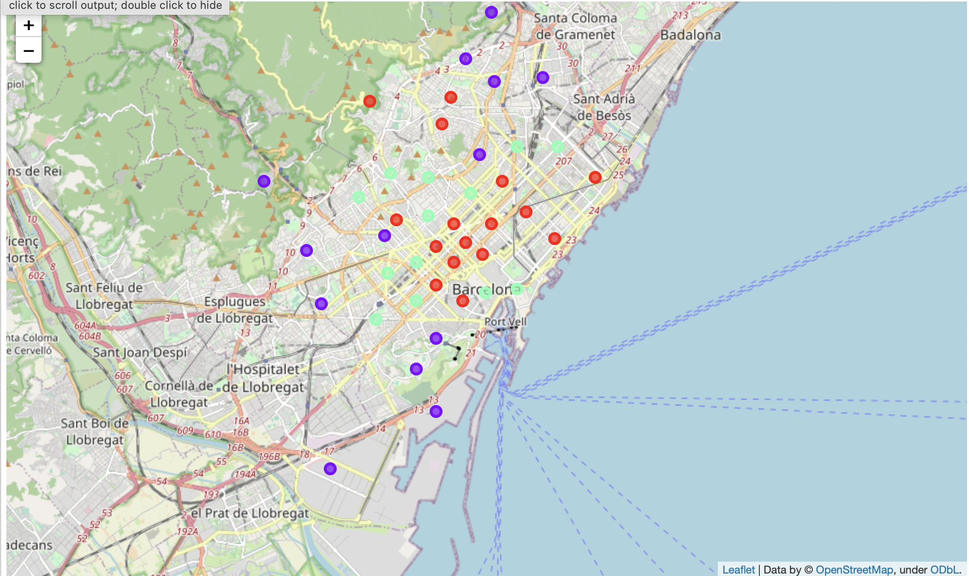

**Discussion**

By observing the exploratory data analysis, one can easily observe that whilst neighborhoods are more or less equally spread across the city, there’s substantial total population differences between neighborhoods.

Also, the % of population above 65 years of age across neighborhoods differs from around 10% to 28%, which is quite a significant spread.

Additionally, the number of interesting nearby venues per neighborhood varies widely from 0 up to 13 venues.

So, a standardisation of the data is necessary prior to performing the K-Means clustering algorithm.

By performing the K-Means clustering algorithm, and looking at the resulting clusters, one identifies that the 3 clusters equate to:

* Cluster 0: low population, low population over 65 years of age and low number of interesting venues
* Cluster 1: inbetween clusters 0 and 2
* Cluster 2: high population, high population over 65 years of age and high number of interesting venues

**Conclusion**

Therefore it seems reasonable to suggest that the selected neighborhood to install the funerary parlour commercial office should be within cluster 2.

Looking at the Cluster 2 neighborhoods:

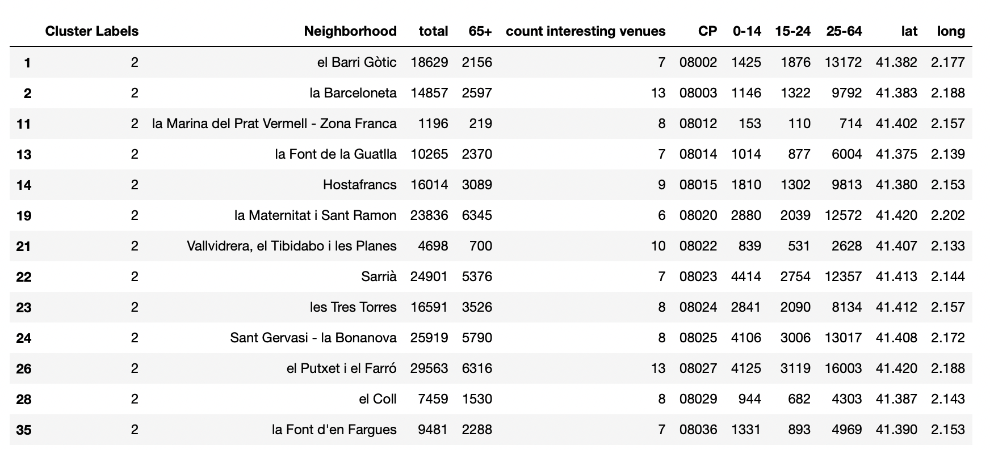

My recommendation to the client would be to install a funerary parlour commercial office in either of the following neighborhoods: 08020, 08025 or 08027.